In this lecture lets see how to use action creators with network requests, ie, how to make api calls when working with redux.
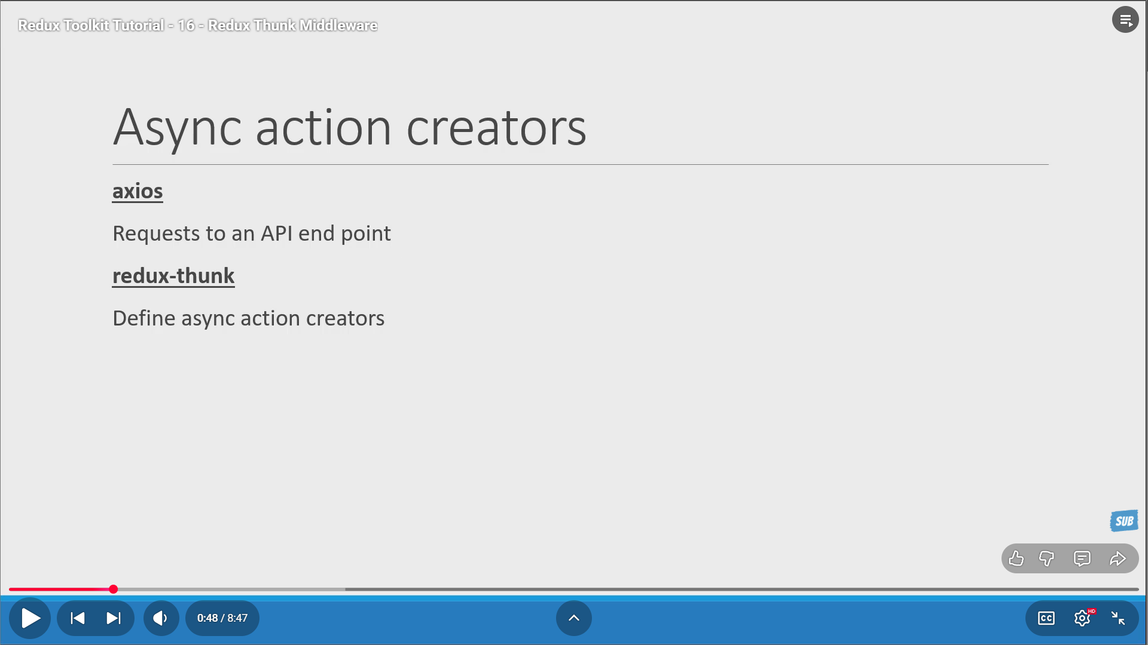
We will need 2 packages – axios, redux-thunk
Redux-thunk is the standard way to create asynchronous action creators. Redux-thunk library is basically a middleware that we will be applying to the redux store.
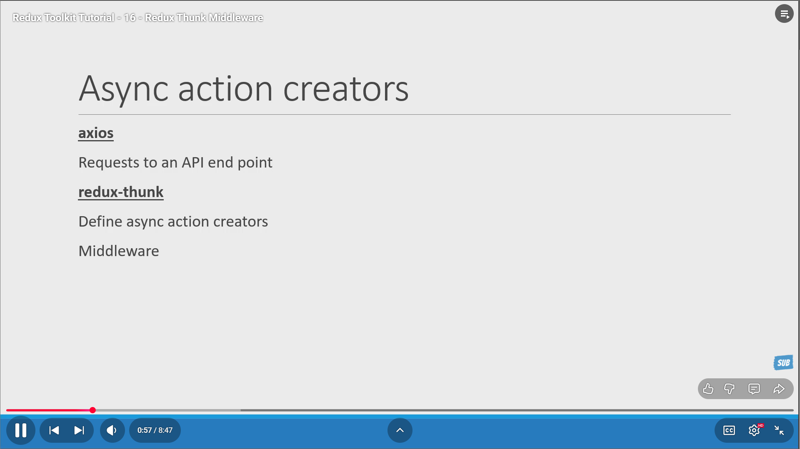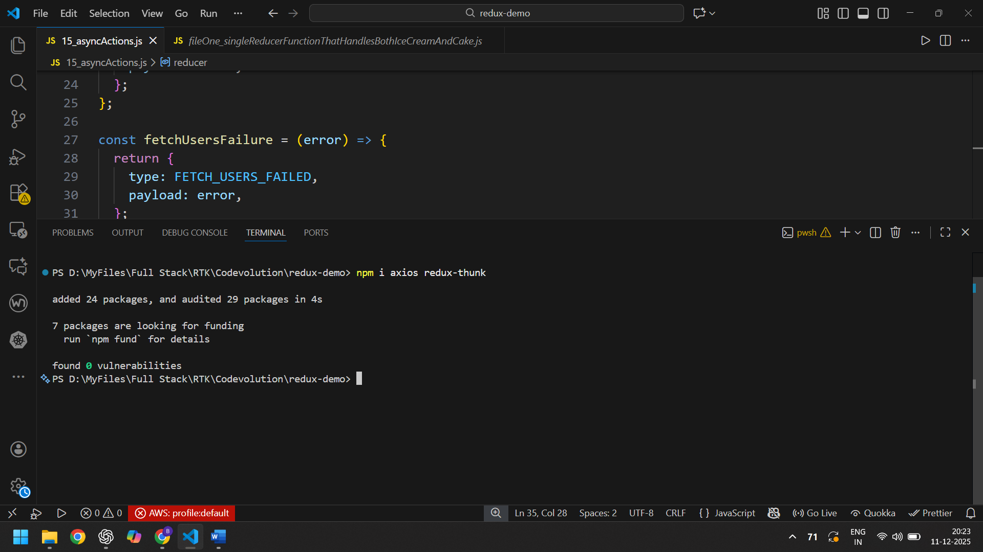

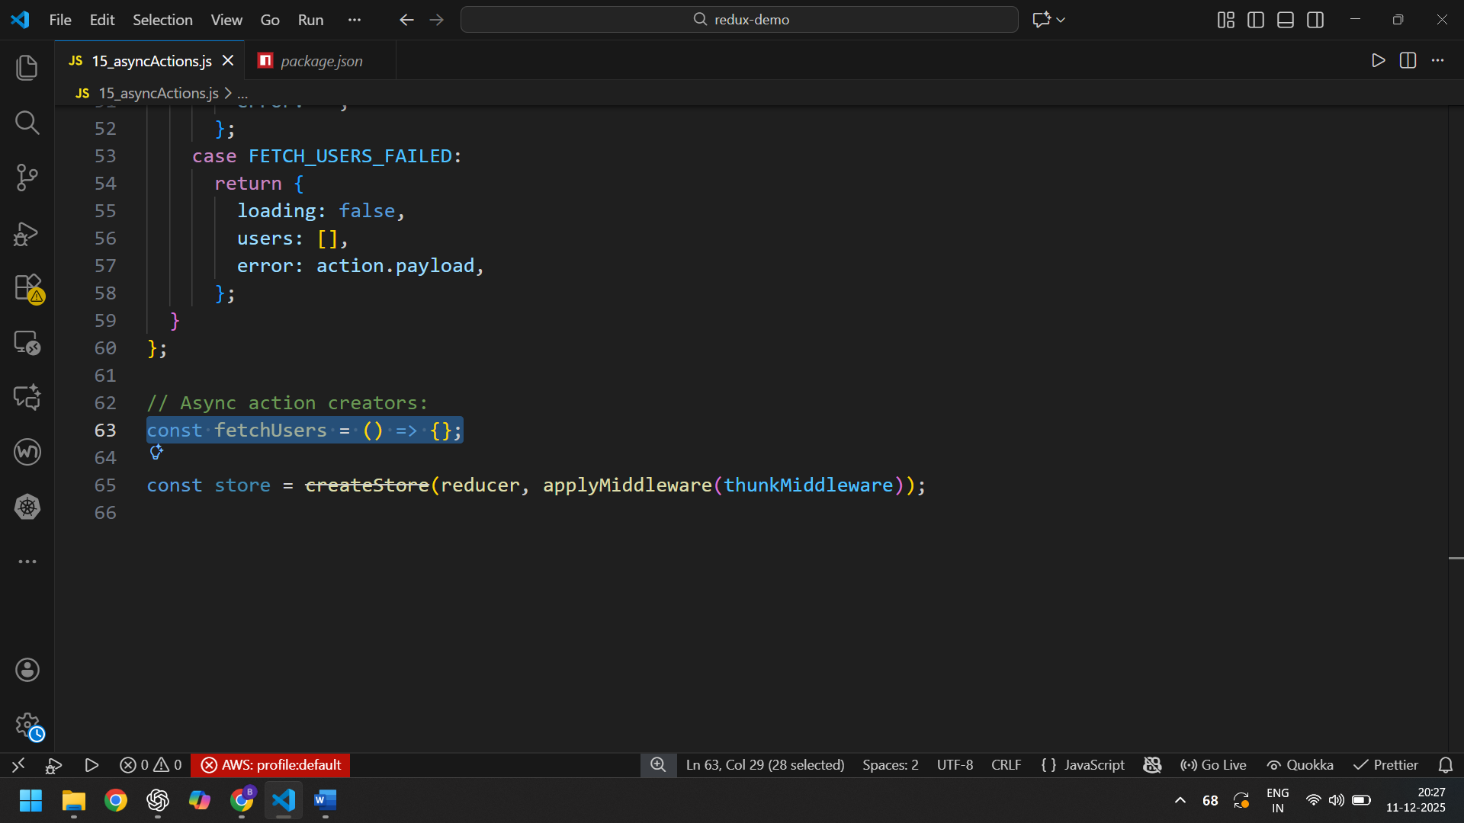
63, fetchUsers() IS AN ACTION CREATOR. WHAT WE KNOW SO FAR IS THAT ACTION CREATOR RETURNS AN ACTION (OBJECT). BUT WHAT THE THUNK MIDDLEWARE BRINGS TO THE TABLE IS THE ABILITY FOR AN ACTION CREATOR TO RETURN A FUNCTION INSTEAD OF AN ACTION OBJECT.
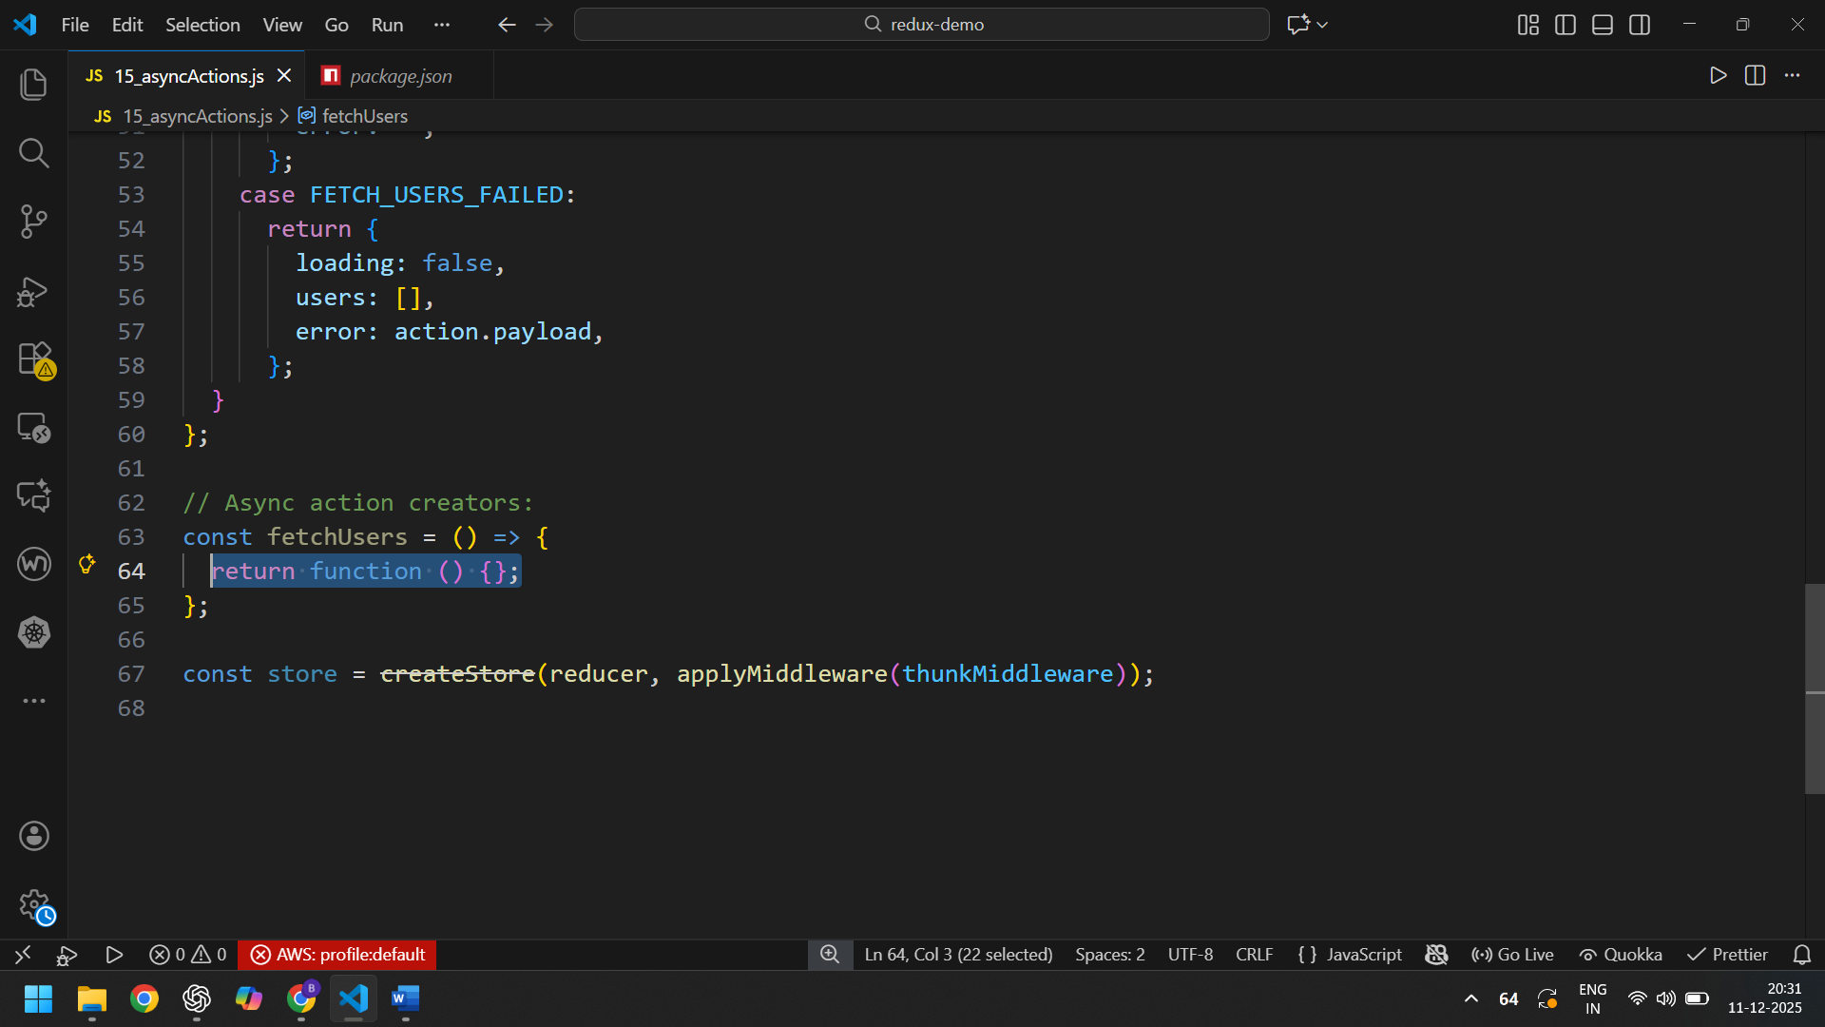
64, THE RETURNED FUNCTION AT 64 IS ALLOWED TO BE IMPURE AND DOESN’T NECESSARILY HAVE TO BE PURE. THE RETURNED FUNCTION AT 64 IS ALLOWED TO HAVE SIDE EFFECTS LIKE API CALLS. THIS FUNCTION CAN ALSO DISPATCH ACTIONS. THIS IS BECAUSE IT RECEIVED dispatch METHOD AS ITS ARGUMENT.
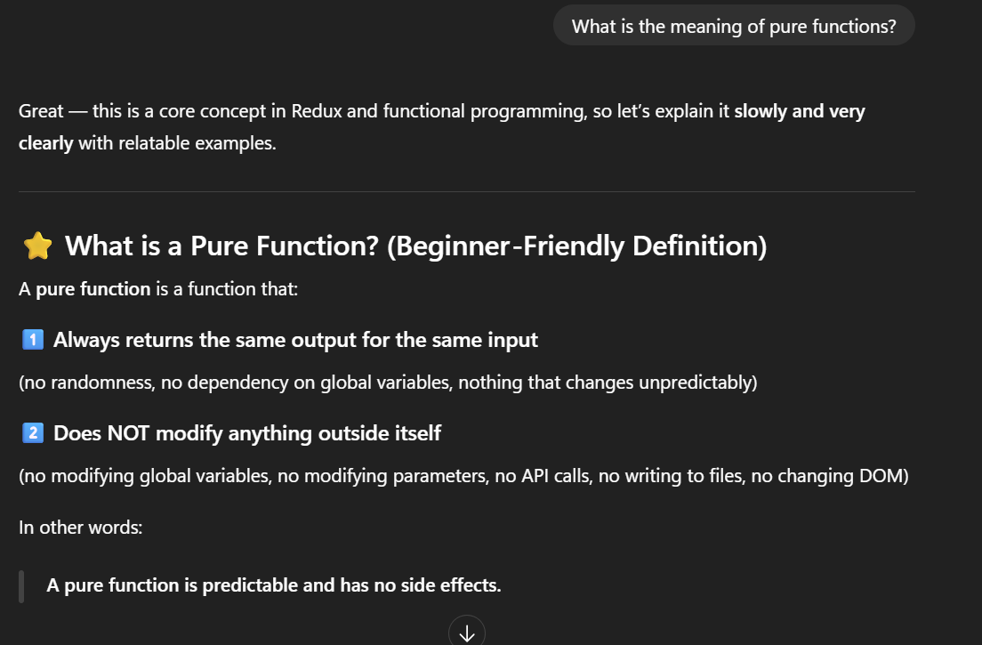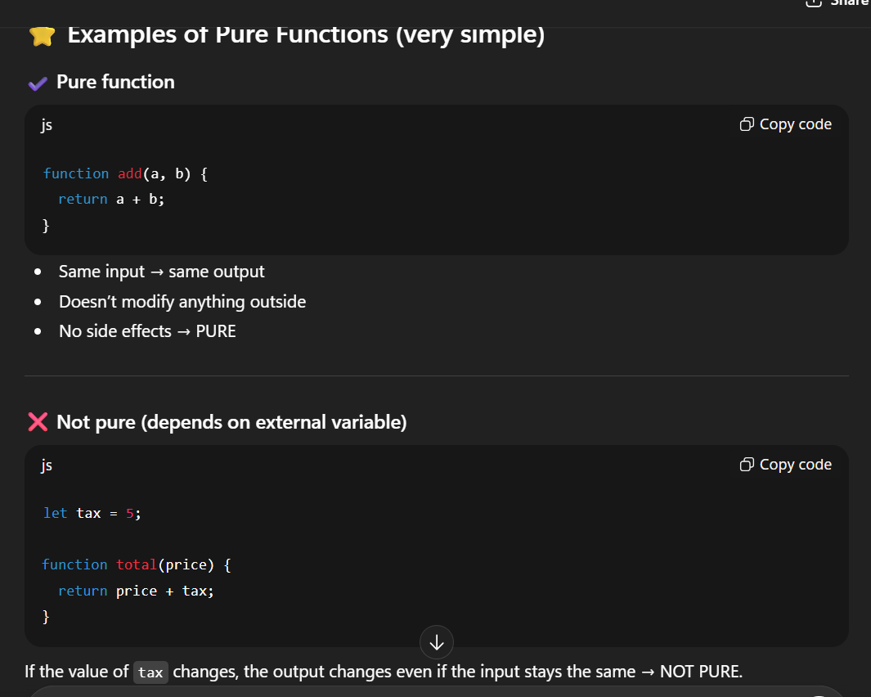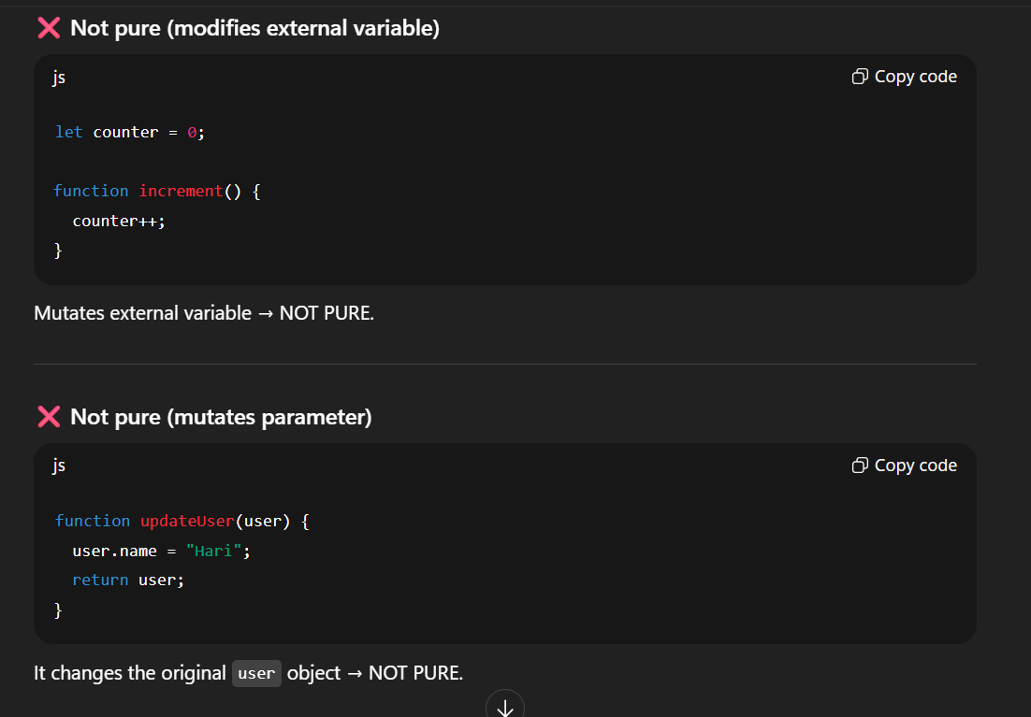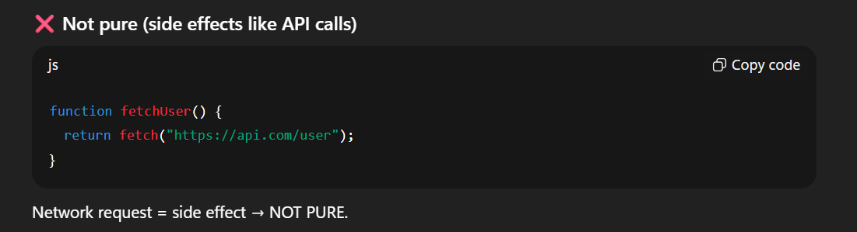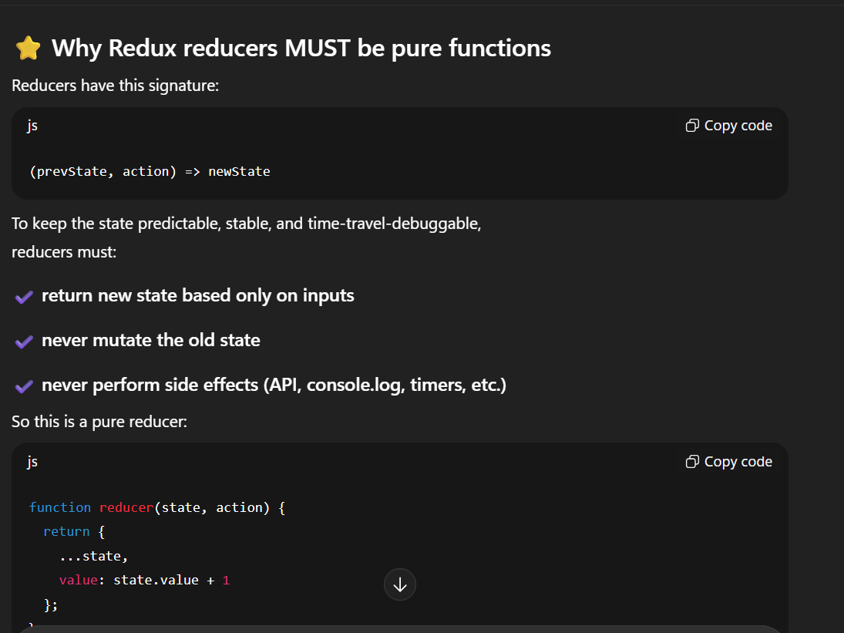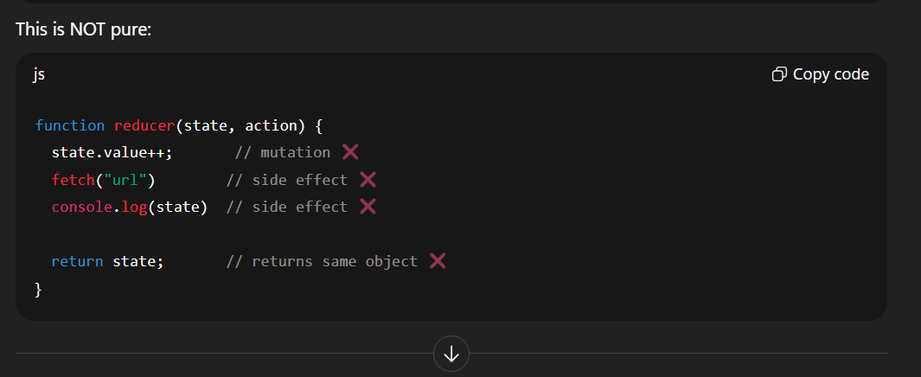

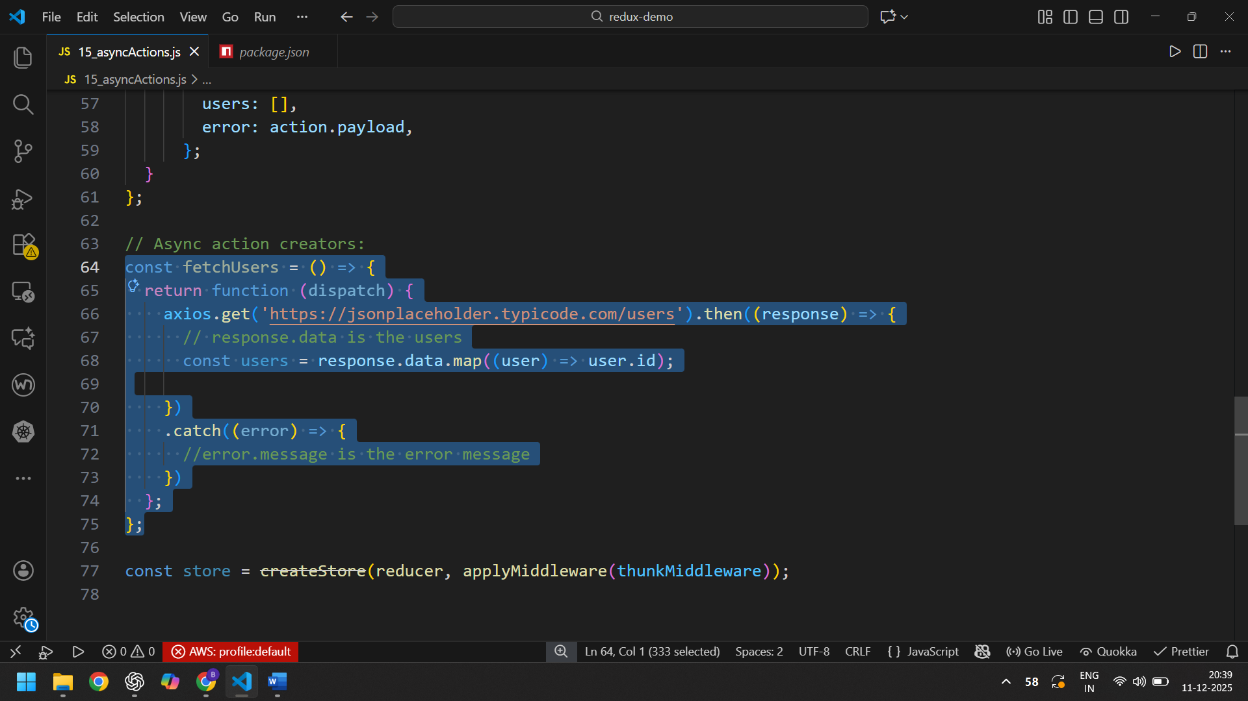
66, WE HAVE MADE THE AXIOS REQUEST.

